# Welcome to the Defenders of the Dojo

# Master Stevens Video Game Challenge

# SURVIVE THE ULTIMATE JOURNEY!

# COMPLETE AND WIN !

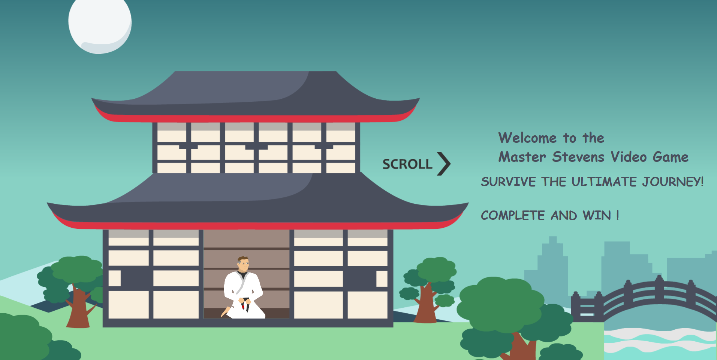

Help Master Stevens ! Navigate the dangers, Brave your way through robots, Alien karate boards and Social Media Monsters. Set off on a platforming adventure,unlock new online Martial arts workouts and learn our life skill curriculum. Explore 3 different paths of enlightenment: The Social Media city - The Sea of Knowledge -and The Mystery Mountain Dojo.

Team up with Master Stevens in this adventure -The fate of the DoJo is in your hands!

BRAND CHAMPION

*This is text for “ YES” PATH*

RULES: You must complete all the actions to get on Our scoreboard Please get help and permission from your parents to complete.Thank you and Good luck!



FACEBOOK

1.Leave a Review (facebook calls it a recommendation)

2. Please LIKE 5 posts -

Make at least 1 comment on latest post - AND SAY “ YES I CAN ”



GOOGLE

Google please leave an honest google review about our program

If you are a student with us. (Get help from your parents)



Please LIKE (Heart) 5 photos and

Make at least 1 comment on latest post - AND SAY “ YES I CAN ”

*get your parents help



Youtube -Please LIKE (thumbs up) 5 video’s

Subscribe to Bill Stevens Karate youtube page



“ NO” PATH